Math Department Blurbs 2020-21

Calculus CP – is a class designed for students who want to learn Calculus on a slower pace without the stress of the AP test. It is recommended for students who want a jump start on Calculus that they would take in college as all concepts will be re taught in semester one of Calculus at the college level. Students who earned a C in IM3H or any student who took Trig and passed should succeed in this class. A firm understanding of all mathematics that has been learned previously will be required to succeed in this class.

AP Calculus AB – is recommended for students who earned an A or B in IM3 honors or at least a C in Trig. This class will use all mathematics learned previously and is a good class to take for anyone interested in a STEM major or just wanting to earn the AP credit so that they won’t have to take math in college. Depends on the school whether the units will count at all, will count towards math credit or will count as elective credit. 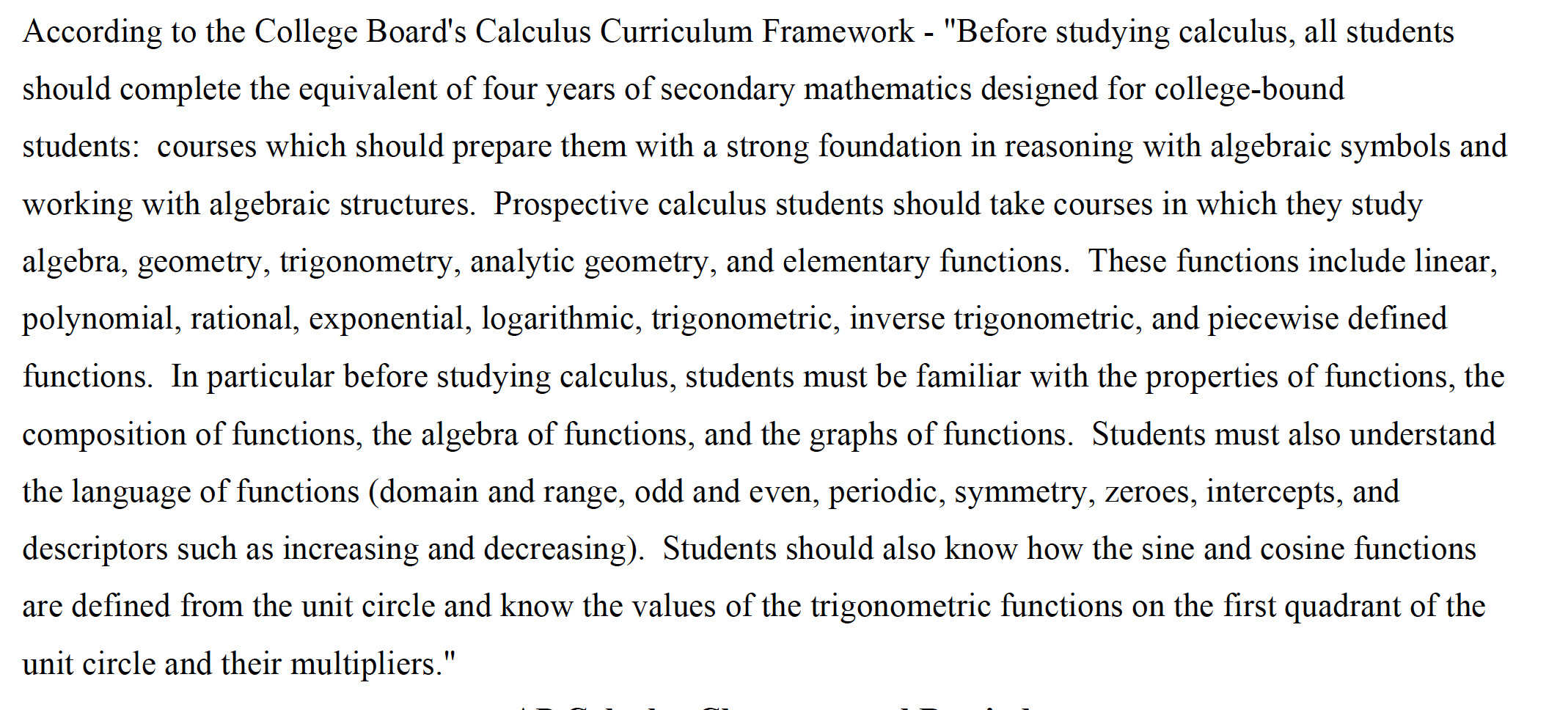
AP Calculus BC – Same as above, but for students who successfully completed AP Calculus AB or CP with a C or better or a passing score on the AP AB test (3 or higher).

MRWC - Mathematical Reasoning with Connections (MRWC) is designed to prepare students for the expectations and rigor of college mathematics. MRWC emphasizes collaborative exploration of rich mathematics through innovative activities and engagement with technology. Students will expand their existing mathematical knowledge into new, advanced areas by making connections between old and new topics. The topics to be explored include reasoning with numbers, reasoning with functions, and reasoning with equivalences. Students should be prepared to work hard, take notes, ask questions, and seek extra help when needed.

To sum it up, I would say, we are going to take the concepts you learned in IM1-IM3 and expand on them in a more interactive way. There is a bit of review but its not reteaching.

The Prerequisites for MRWC are IM1-IM3 with a C or better. Its very important that students with a C or greater in IM3 are allowed into MRWC.

Financial Algebra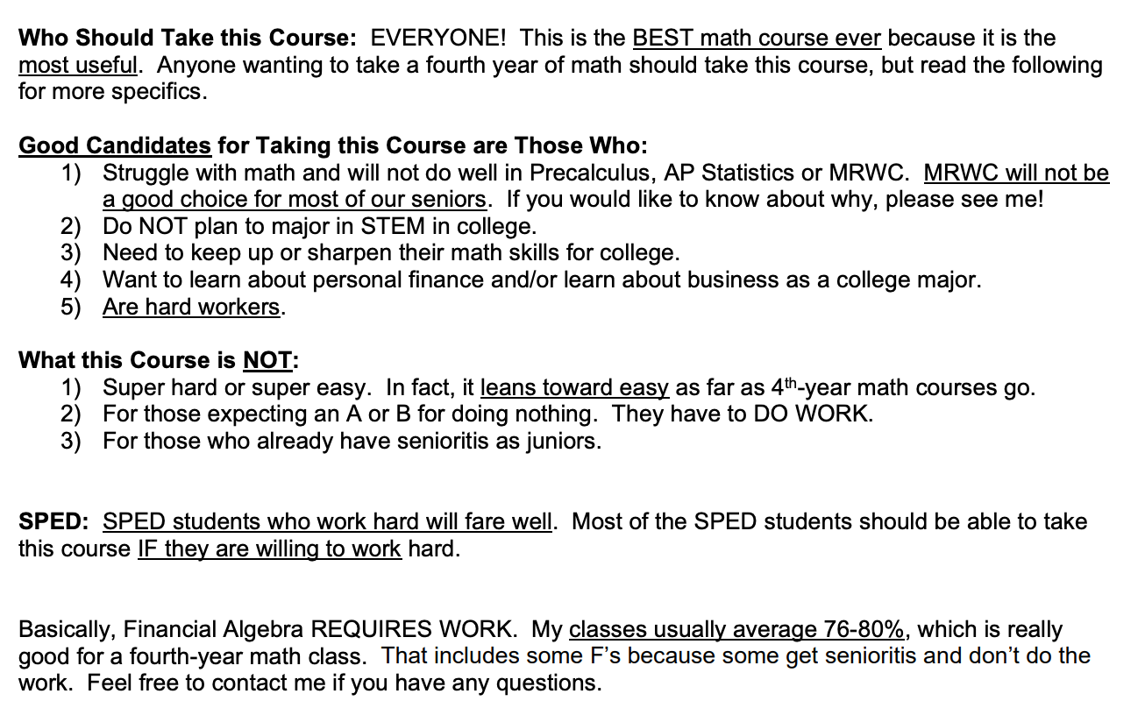

I am still waiting on Prob and Stats and AP Stats – those classes are great for all students after successfully passing IM3 who want a fourth year of math. It’s not an easy class, but the math is not difficult. There is a lot of reasoning, deciphering and testing. I’ll let you know what Mac sends me once he does.

